MTH 200 | Techniques for Computing Limits

Directions: Solve all problems on a separate sheet(s) of paper. Place your name on the pages you submit. You must show all of your work to receive full credit on problems. You must write complete sentences when asked to show/prove something or provide an explanation/justification. You are encouraged to work with others, consult sources, use calculators, etc. However, only submit solutions that you fully understand. Do not submit solutions which are copied from a friend or another source.

Challenge Questions

- Compute the limit

- If for all x, determine

We see that and

Therefore, by the Squeeze Theorem we know that .

- Determine the horizontal and vertical asymptotes to

A vertical tangent would occur at x values where the denominator equals 0 and the numerator doesn’t equal 0. We see that . Therefore, there is a vertical asymptote of

Horizontal asymptotes of the graph can be found by computing .
We calculate that

Therefore has two horizontal asymptotes: .

- Is there a value of a such that exists?

We see that . If the numerator is divisible by then the limit will certainly exist.

We calculate that

To makedivisible by it must be the case that the remainder is 0 and therefore we need

So, if then

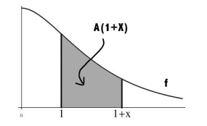
- The function f is continuous and decreasing on . Define to be the area from 1 to under the graph of f and above the x-axis (as shown in the picture below).

Compute . Hint:
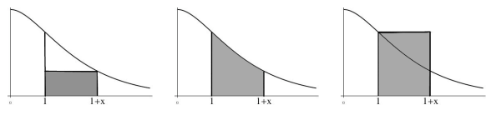

We see that and this implies that . We note that and . Therefore, by the Squeeze Theorem, it must be the case that .

- TRUE or FALSE: If neither nor exists, then must not exist.

FALSE: Consider the functions and and let . Clearly DNE but and therefore exists.

- TRUE or FALSE: If does not exist then it must be the case that either or do not exist.

TRUE: Notice that if the statement was false then it would be the case that both & exist and yet DNE, however this directly contradicts the limit law that we have which states that if & exist, then which implies that must exist.

